# SumX Function

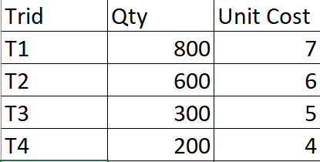

**Rename Sheet1 to Sales**

We want to have summation of Qty into Unit Cost of every record.

Create a **New Measure**:

**Grand Total of Sales =**

**SumX(Sales, Sales[Qty] * Sales[Unit Cost])**

How does it work??

**Ans. SUMX is an Iterator Function.**

SUMX will go through every single record of the input table

and run the expression for that record,

it stores the result of that into a temporary memory.

Mechanism is as follows:

1. Iterate over the Sales table, stepping row by row
2. Calculate Sales[Qty] * Sales[Unit Cost] at each row
3. In the end, sum all of them up to give us our Grand Total of Sales